So far, we have learned these below topics:

1. Connection of different networking device: Switch, Hub, Bridge
2. Router to LAN
3. Router to Router (Static Routing)
4. Dynamic Routing, Default Routing
5. Subnetting
6. VLSM
7. Server as File Server, DHCP server, DNS Server
8. DHCP using Router

Now complete the connection of the given topology with few restrictions and rules.

1. last octate of the IP address of “Name PC” should be the last 3 digits of your roll number (Static Host)

For example, if roll: 1803090 then IP address of “Name PC” can be like 192.170.100.90

1. Use **Dynamic Routing** for the connection.
2. Assign the **DNS** name to “Name PC” as your Name.
3. Assign IP addresses to all the host by **DHCP** except “Name PC”.
4. You have flexibility to use any network address for each network in the topology.

Modify this packet tracer file: <https://rebrand.ly/CN11Week>

Rename the file according to your roll and submit it.

**DHCP:** Some clarification:

You need not create a different pool for the same network where the DHCP server is. Just modify the ServerPool. 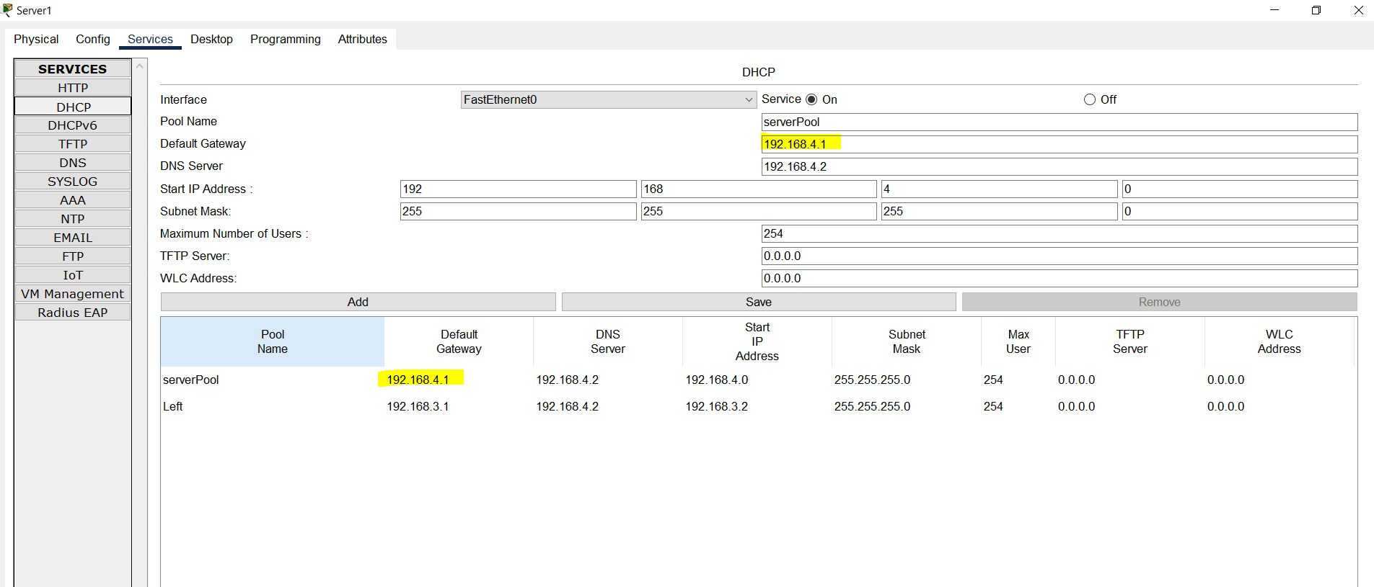

Link: https://rebrand.ly/DNS_DHCP

**DNS (Domain Name System)**

Study Link: https://computernetworking747640215.wordpress.com/2018/07/05/dns-server-configuration-in-packet-tracer/